Traditional Chatbot with AI Service Project

Trey Williams
University of the Cumberlands
MSAI-631-A01: Human-Computer Interaction.
Dr. Alan Dennis
September 13, 2026

Traditional Chatbot with AI Service Project
Traditional chatbots use rule-based algorithms to provide responses to users. While this is a powerful approach, it lacks the adaptability that can be addressed by incorporating artificial intelligence into the programming. In the original project, deterministic if/elif logic was used to identify movie genres and return recommendations. In this project, Azure AI Language sentiment analysis was added while preserving the original rule-based recommendation logic. This integration demonstrated how AI can be incorporated into a locally functioning traditional chatbot through AI-as-a-Service (AIaaS). It also improved human-computer interaction by allowing responses to adjust based on user sentiment and by providing practical experience connecting Python code to a cloud-based AI service.

Existing MovieMatch Chatbot
The original MovieMatch chatbot consisted of a simple program that could accept user input, convert it, match it to keywords, and provide a recommendation. The model was also able to provide a help command, handle blank and unsupported input, and support a termination command. The program was functional at a basic level but lacked features a user would expect from a more advanced chatbot. This was because the original chatbot did not use machine learning or generative AI. Because the model was already functional, easy to understand, and easy to build upon, it was used to develop the next version. This allowed for a clear delineation between a traditional rule-based model and an AI-enhanced model (Kore, 2022).
Selecting the Azure AI Service
To implement AI functionality into the chatbot, Microsoft Azure AI Services was selected. By using the free tier of Azure AI Language, the project gained access to sentiment analysis capabilities. This service was a good fit for the chatbot because it enhanced the program’s functionality without replacing the original recommendation logic. AI-as-a-Service allows organizations and developers to access AI capabilities through externally hosted services rather than building the entire AI infrastructure themselves (Lins et al., 2021). The added functionality enabled the system to analyze the emotional tone of the user’s request, and MovieMatch adjusted its conversational response accordingly. The traditional keyword logic then continued to determine the movie recommendation. Examples of this interaction included:
- negative sentiment → supportive response;
- positive sentiment → upbeat response;
- neutral sentiment → general response.

Azure Configuration and Security
Establishing the Azure configuration was one of the challenges I encountered during the project. After signing up for a student account, I attempted to configure the Azure Language sentiment analysis resource. To accomplish this, I had to name the project and select a region for the cloud service. This process was more difficult than expected because the region I initially selected did not support the required resource. I had to manually change the region until I found one that worked.
After the resource was successfully created, I used the search function to locate the Keys and Endpoint section. Microsoft identifies this section as the location to obtain the resource key and endpoint for authenticating Azure Language requests (Microsoft, n.d.). Because of the sensitive nature of the API key, I stored it in Google Colab Secrets rather than placing it directly in the source code. This was important because Microsoft recommends that API keys not be included directly in application code or posted publicly and that credentials be stored securely (Microsoft, n.d.). This approach reduced the risk of accidental credential exposure, prevented the key from being committed to GitHub, and separated sensitive configuration information from the application logic.
I initially believed the Azure Language API call would also require the region to be stored as a secret. During testing, I determined that the region was not required for the API request, so I removed it from the secrets configuration. This simplified the setup and ensured that only the information actually required by the application was retained.

Initial Development and Azure API Testing
To begin development for this project, I used the original Python code from the previous project as a functional base for the new application. This allowed me to build on code that was already working rather than starting from scratch. Before integrating Azure sentiment analysis into the full program, I tested the API call in a separate Google Colab cell. This helped isolate any configuration or connection issues before they affected the rest of the application. Microsoft documents that Azure Language sentiment analysis requests use the Azure resource endpoint and authentication key to submit text for analysis and return sentiment results (Microsoft, n.d.).
The first API test failed because I used the wrong API URL. After identifying and correcting the URL, the API call worked successfully and returned the expected sentiment analysis results. Once the Azure connection was verified, I integrated the sentiment analysis code into the existing project. This approach reduced unnecessary troubleshooting and allowed me to reuse the existing application structure rather than recreating components that were already functioning.
After integration of the Azure Language sentiment analysis API call, I tested the code again. This produced an HTTP status 200, sentiment classification, confidence scores, and a sentence-level analysis. After this response, I changed the code to process the sentiment more colloquially. I typed “I had a terrible day and want something funny.” Azure returned a positive sentiment result. While this showed that the analysis technically worked, it showed an incorrect analysis. This demonstrated that the key worked, the endpoint worked, the requested format was correct, and Colab was communicating properly with Azure.

Azure With MovieMatch
At this point, the code was functioning, but it was not yet returning the exact response needed for the project. The analyze_sentiment() function sends the user's text to Azure AI Language, receives the response, extracts the sentiment label, and returns that result to the chatbot. Azure sentiment analysis evaluates submitted text and returns sentiment labels, such as positive, neutral, or negative, along with confidence scores (Microsoft, n.d.). Separating the Azure functionality from the main chatbot logic made the program easier to understand, test, and troubleshoot while preserving the original MovieMatch structure.
The resulting program flow accepts user input, handles blank entries, local commands, and exit commands, and sends movie-related input to Azure for sentiment analysis. After Azure returns the sentiment result, the program generates a sentiment-aware response and then executes the original if/elif movie-recommendation logic locally. This ensured that Azure supplemented the traditional chatbot rather than replacing it. The original rule-based logic remained responsible for the movie recommendations, while Azure provided an additional AI-based capability.
This approach also provided an advantage from an enterprise perspective, as limiting cloud API calls can reduce resource consumption and operating costs. Azure Language pricing is based on the number of text records submitted for analysis, while the Free tier currently provides up to 5,000 text records per month across supported Language features (Microsoft, n.d.). After reviewing the project's Azure usage, I found that the application had generated very little activity and had not consumed a significant portion of the available Free tier allocation.

Human-Computer Interaction and Usability
The inclusion of AI in this project improved the quality of the user experience. Sentiment analysis changed the user experience by providing more feedback than simply returning a movie recommendation from the dictionary. The original MovieMatch program could respond only to explicit keywords, with little variation in conversational tone. The addition of AIaaS enhanced the program’s usability by allowing it to recognize the user’s sentiment and adjust the response accordingly. This type of adaptation supports a more human-centered interaction because the system becomes more responsive to the context of the user’s input rather than relying only on predetermined commands (Kore, 2022). Examples of this include:
- positive → “Sounds like you're in a good mood!”
- negative → “Sounds like you could use a good movie today.”
- neutral → “Let’s find something for you to watch.”
This approach made the interaction feel more responsive while still preserving the predictability of the original rule-based chatbot. The help, blank input, and exit commands were handled locally rather than being sent to the cloud. This provided a faster and more predictable experience while also avoiding unnecessary API calls and preventing inappropriate sentiment responses to commands such as help. AIaaS is most useful when applied selectively to functions that benefit from AI capabilities, rather than replacing every component of an existing system (Lins et al., 2021). In this project, AI was therefore used to add value to the interaction, while simpler functions were handled locally.

Testing
The next step was testing the overall chatbot. Testing included both the original and new functionality. These tests included the help function, negative mood, positive mood, neutral mood, nervous, a nonsense input, and the termination function. The help function worked normally. All of the genre recommendations also worked. The invalid input produced the correct fallback. The termination function also worked correctly in all tests. The issue was the sentiment response. Initially, these did not work correctly, and also gave a sentiment for the help function. After editing the code, this was fixed (see figures 4 and 5).
Challenges and Mitigation
Many challenges were encountered during this project, but each was mitigated through testing and troubleshooting. The first challenge involved using the wrong URL. Initially, the URL in the instructions was used, resulting in a 404 error. I then realized I needed to use the endpoint URL for my own Azure resource. This allowed the code to send the API request to the correct resource location. The next challenge was verifying that the API itself functioned correctly. I mitigated this by using a separate notebook cell to test the service before integrating it with the original MovieMatch code. This allowed me to confirm a successful 200 status response and isolate the API connection from the rest of the application. Using managed AI services requires developers to correctly configure service endpoints and external resources before those capabilities can be integrated into an application (Lins et al., 2021).
Another challenge involved protecting AIaaS credentials and adhering to proper cybersecurity practices. API keys should not be placed directly in Python code or exposed through a GitHub repository. To mitigate this risk, the Azure key was stored in Colab Secrets rather than being hard-coded into the application. Separating credentials from the application code reduced the likelihood of sensitive information being unintentionally exposed while still allowing the program to authenticate with Azure. The use of cloud-based AI services introduces additional governance and access-control considerations because developers rely on externally hosted resources and service credentials (Zapadka et al., 2020).
A final challenge involved sentiment results that did not always match human expectations. An example of this can be seen in Figure 4, where the model returned a positive sentiment even though the wording appeared negative. In another test, a statement intended to be neutral was also classified as positive. Sentiment analysis is probabilistic rather than deterministic, meaning the model can produce classifications that differ from human interpretation. I mitigated this limitation by using the AI model only to adjust the chatbot’s conversational tone rather than allowing sentiment to change the actual movie recommendation. This ensured that the core function of MovieMatch remained predictable while still benefiting from AI-enhanced interaction. Human-centered AI design should account for the limitations of AI outputs and preserve appropriate levels of reliability and user control when AI is incorporated into an interface (Kore, 2022).

What I Learned
This project was the first time I used a cloud-based AIaaS capability integrated into a local program. It demonstrated the practical differences between traditional programming, cloud-based AI services, and generative AI. I learned that AI can be added to a traditional chatbot without replacing the entire system, which can improve the user experience while also limiting unnecessary use of cloud resources. I also gained practical experience with REST APIs, including endpoints, headers, API keys, request bodies, JSON responses, and HTTP status codes. AIaaS allows developers to access externally hosted AI capabilities without having to build or maintain the underlying AI infrastructure themselves (Lins et al., 2021).
Cloud AI integration involved more than simply writing Python code, which is the area I am most comfortable with. I also had to learn how to troubleshoot 404 and 401 errors, which required a better understanding of service configuration, authentication, and resource endpoints. Another important lesson was that AI output is not always intuitive or perfectly aligned with human interpretation. This reinforced the value of deterministic logic because it remains predictable, explainable, and easier to test. AI is a useful tool, but it should be applied selectively rather than unnecessarily, particularly when cloud usage introduces additional cost or complexity. From an enterprise perspective, it can be more efficient to process simpler functions locally and reserve AIaaS calls for tasks where AI provides clear additional value (Hajipour et al., 2023).

Interesting and Exciting Aspects
Watching the local Python chatbot communicate with the cloud AI service in real time was one of the most interesting parts of the project. I was able to observe both sides of the transaction by seeing the request leave the local code, appear in the Azure logs, and then return to the program as a response. Another interesting aspect was adding the cloud AI capability to the existing chatbot, almost like placing a “hat” on top of the original code rather than completely rewriting the application. This demonstrated that a relatively small amount of additional code can connect a simple local program to a much larger cloud-based AI infrastructure. AIaaS also showed how machine-learning capabilities can be added without the time, expense, and technical complexity required to develop and maintain a proprietary AI model (Lins et al., 2021).

Current Project Improvements
There are several areas that could be improved in a future version of the project. The Azure setup was more confusing than expected, and it took longer to configure and get the API running successfully than it did to develop the rest of the chatbot. The Azure services were also challenging to navigate because several services and resource types share similar names, making it harder to identify the correct endpoint. The Microsoft documentation could be improved by more clearly distinguishing which APIs and endpoints correspond to specific Azure resource types. Cloud AI services offer significant capabilities, but they can also introduce configuration and integration complexities that must be managed during implementation (Zapadka et al., 2020).
Another area for improvement involves the consistency of the sentiment results. The AI did not always correctly interpret the intended meaning of a sentence, which could cause the conversational response to feel inappropriate or inconsistent. The chatbot code itself also remains relatively rudimentary because it relies on a dictionary-based system rather than a dynamic library of titles, ratings, or other recommendation criteria. Even with AI support, the chatbot remains relatively simple because the sentiment analysis changes only the conversational tone and does not alter the movie recommendation itself. Future development should include testing with a larger set of statements to better evaluate sentiment consistency and reliability before the application can be considered deployable. Human-centered AI systems should account for uncertainty in model outputs and be evaluated carefully before those outputs are allowed to meaningfully affect user-facing decisions (Kore, 2022).

Future Development
Future development of this project is still necessary. One improvement would be to expand the number of movie genres and recommendations available to the chatbot. The sentiment analysis could also be used to influence the recommendation itself rather than only changing the conversational tone. For example, a negative mood could lead to more uplifting or comedic recommendations, while a positive mood could allow for a broader selection of genres. This could be supported by connecting the chatbot to an external movie database with a larger, more dynamic collection of titles. AI-enhanced systems can provide more personalized experiences by adapting outputs to user context and preferences rather than relying solely on fixed responses (Kore, 2022).
Another improvement would be to add limited conversational memory so the chatbot can retain relevant information from earlier parts of the interaction. Additional Azure AI Language capabilities, such as key phrase extraction, named entity recognition, and language detection, could also expand the chatbot’s functionality. Once the application is more mature, a web-based interface and user login system could be added to support personalized recommendations and user-specific behavior. The final stage of development could involve a more adaptive interface that changes elements of the interaction based on user needs, preferences, or behavior. AIaaS provides a practical way to add these capabilities incrementally, without requiring developers to build and host each AI model independently (Lins et al., 2021).
Conclusion
This project successfully integrated Azure AI Language with the traditional MovieMatch chatbot. The original deterministic recommendation system remained functional while Azure added the ability to provide more tailored, sentiment-aware responses. The project demonstrated how AIaaS can enhance an existing application without requiring the development of a custom machine-learning model. It also reinforced the importance of testing, error handling, credential security, usability, and the selective use of AI capabilities. AIaaS can allow organizations and developers to incorporate advanced AI functionality while relying on externally hosted infrastructure and services (Lins et al., 2021). The enhanced MovieMatch chatbot now provides a foundation for more advanced AI and HCI development.

Figures
Figure 1
Azure Language resource / Keys and Endpoint
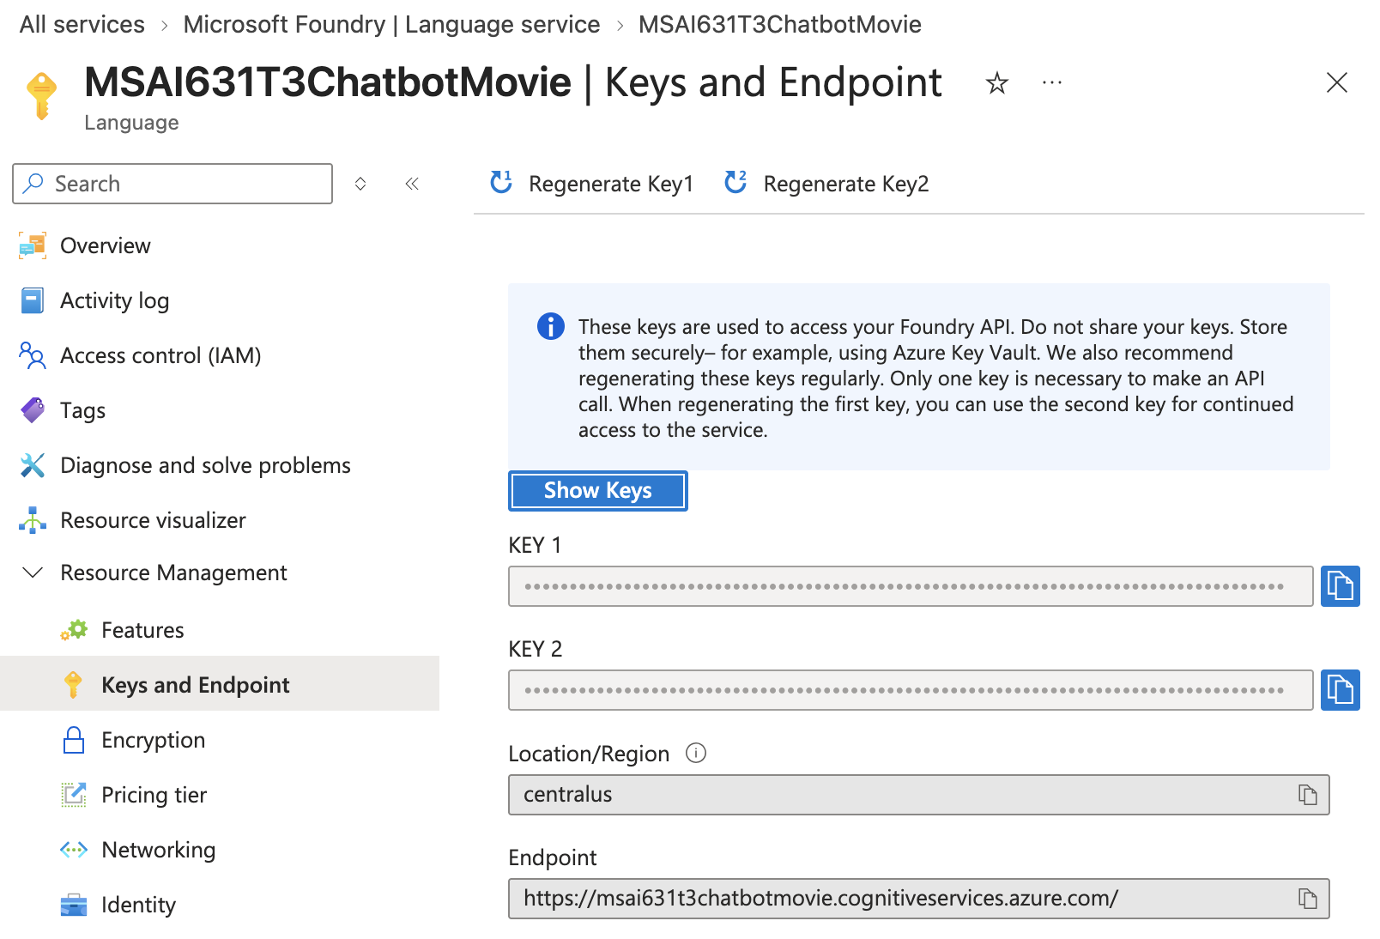
Figure 2
Colab Secrets setup
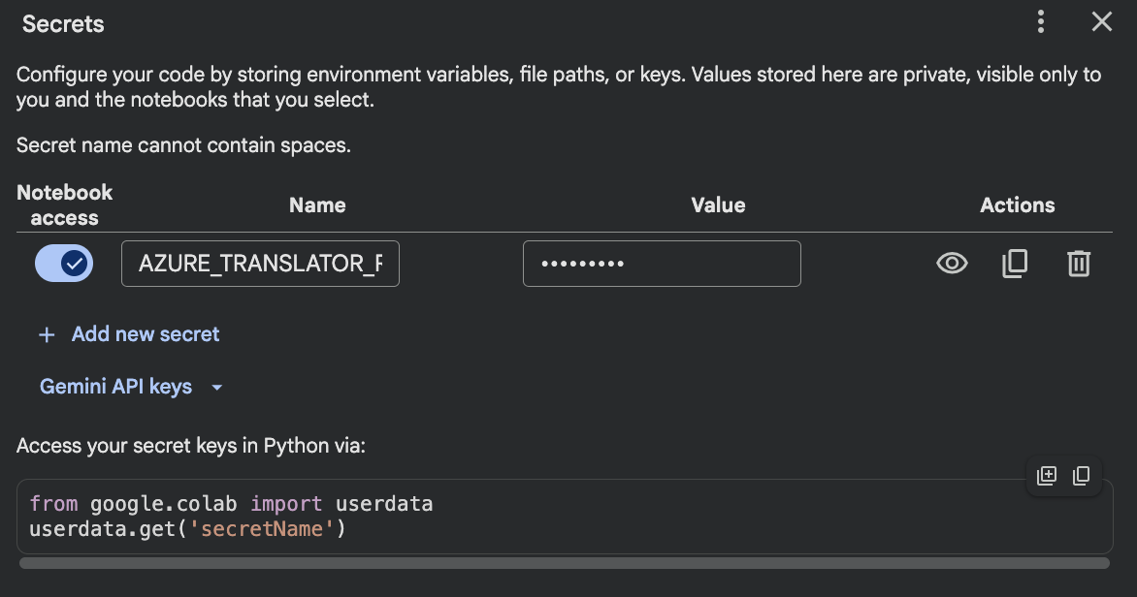
Figure 3
AI integration code
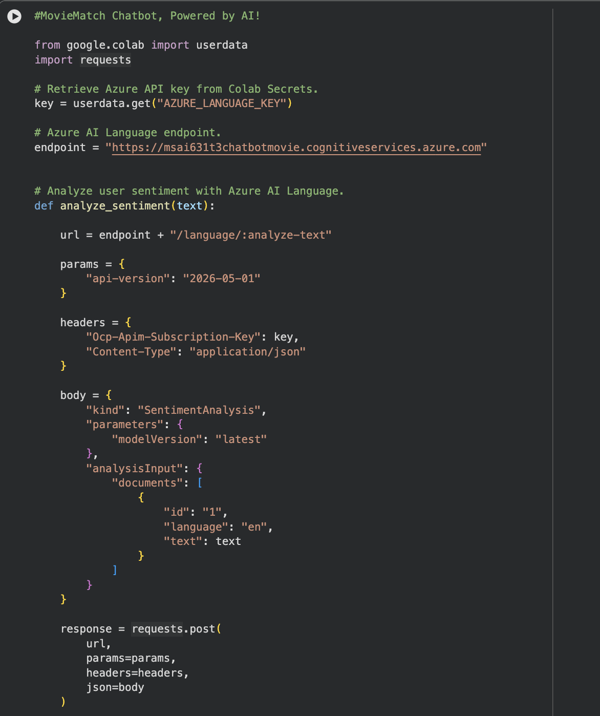
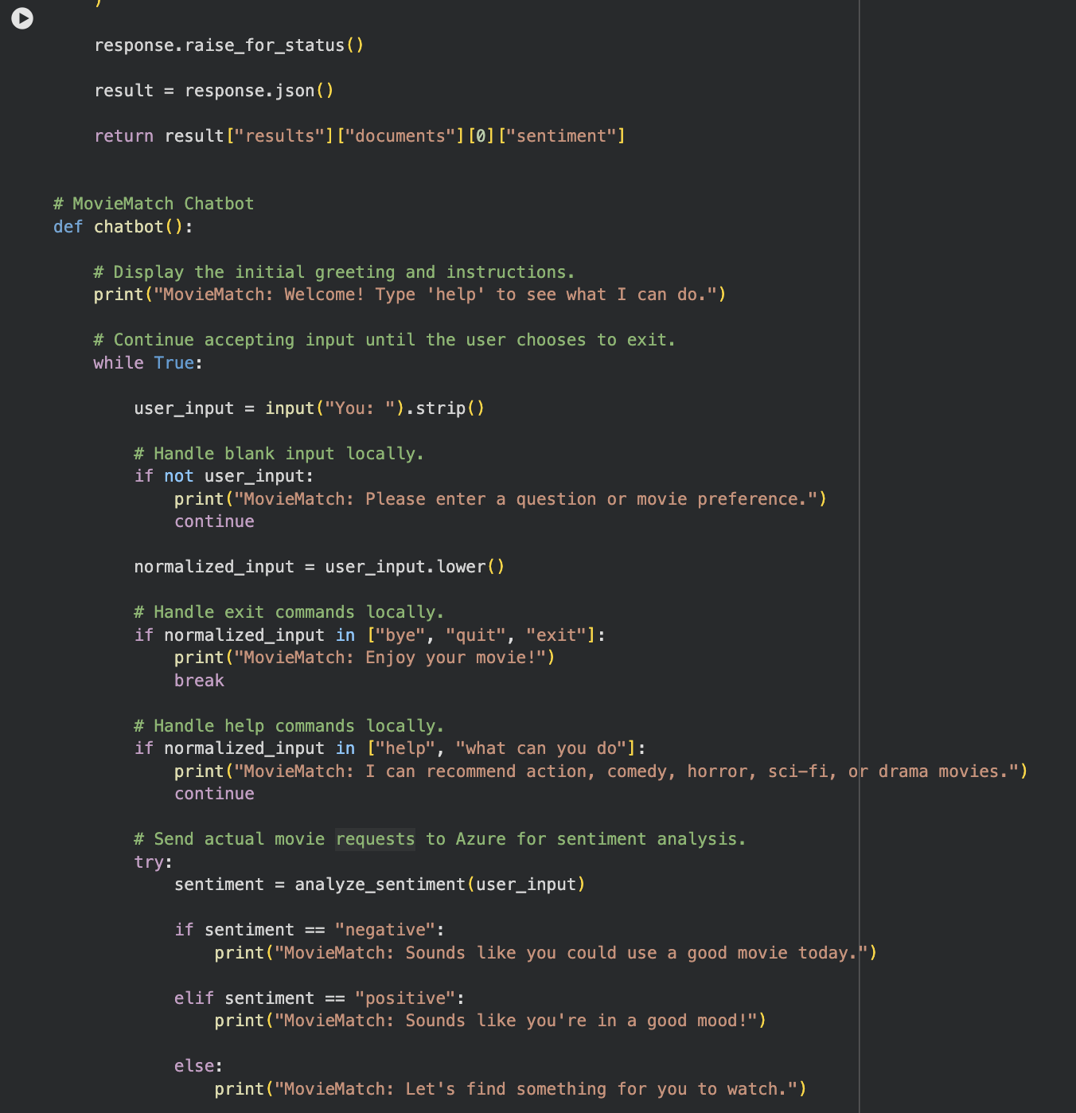
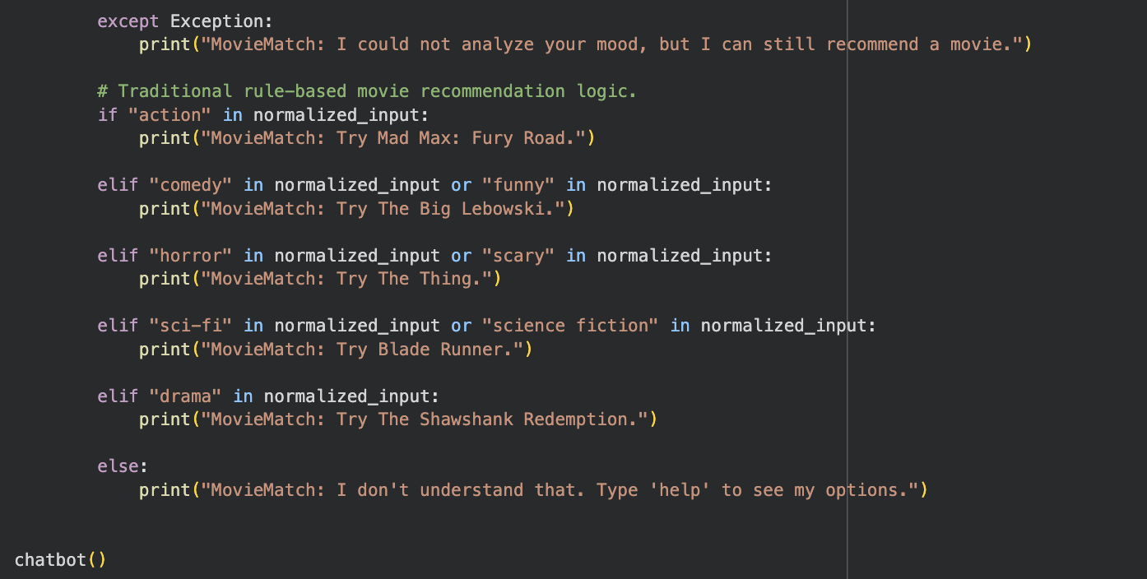
Figure 4
Successful Azure sentiment API response
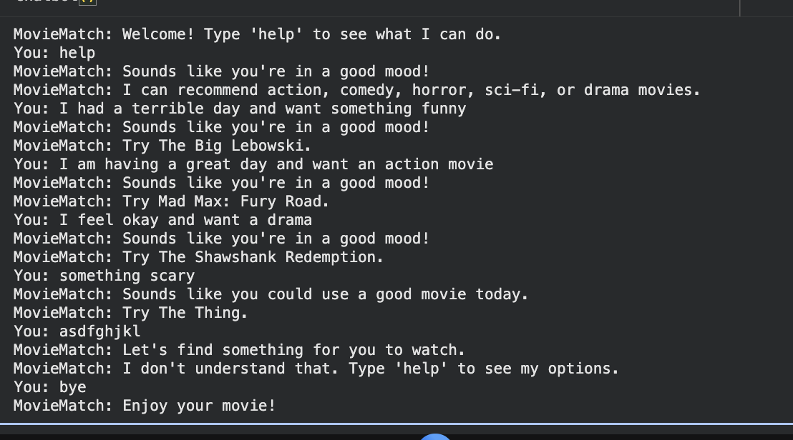

Figure 5
Final successful test conversation
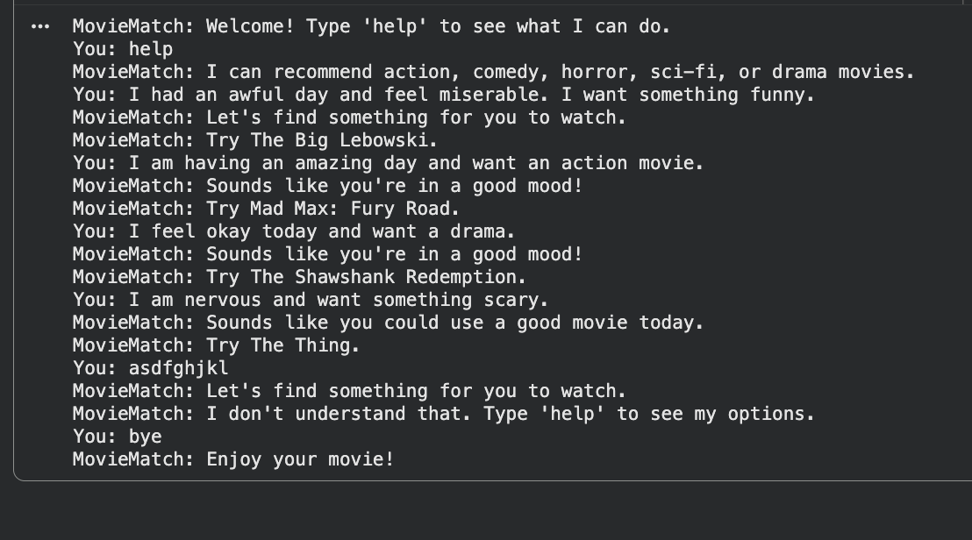

AI Tools and Project Repository Disclosure
I used ChatGPT and Grammarly to support coding, brainstorming, and grammar revision.
I reviewed, verified, and revised all AI-assisted content and accept responsibility for the final submitted work.
Project repository: lunchtrey84/MSAI_631_REPO

References
Hajipour, V., Hekmat, S., & Amini, M. (2023). A value-oriented artificial intelligence-as-a-service business plan using integrated tools and services. Decision Analytics Journal, 8, 100302. https://doi.org/10.1016/j.dajour.2023.100302
Kore, A. (2022). Designing human-centric AI experiences. Springer Nature. https://reader2.yuzu.com/books/9781484280881
Lins, S., Pandl, K. D., Teigeler, H., Thiebes, S., Bayer, C., & Sunyaev, A. (2021). Artificial intelligence as a service: Classification and research directions. Business & Information Systems Engineering, 63, 441–456. https://doi.org/10.1007/s12599-021-00708-w
Microsoft. (n.d.). Integrate AI Services to enrich your applications with intelligent features in Azure Database for PostgreSQL. Microsoft Learn. https://learn.microsoft.com/en-us/training/modules/integrate-ai-services-enrich-azure-database-postgresql/
Zapadka, P., Hanelt, A., Firk, S., & Oehmichen, J. (2020). Leveraging “AI-as-a-service”–Antecedents and consequences of using artificial intelligence boundary resources. Proceedings of the International Conference on Information Systems (ICIS 2020). https://aisel.aisnet.org/icis2020/governance_is/governance_is/6/

